Directions: The goal of the following problems is to help challenge and deepen your understanding of the current topic. Don’t assume that you will know how to answer each and every question. You will work with at least two other students in the class to try and find solutions and write arguments for each of the following questions. Be sure that you question your classmates’ reasoning. If you don’t understand how they are getting something you should ASK THEM TO EXPLAIN! Being able to defend your reasoning is important and so you are actually helping them by asking them to explain.

Challenge Questions

- Consider the graph of the shown below.
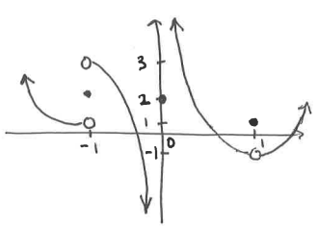

Determine each of the following.
- DNE

- Create a function that has the following properties.

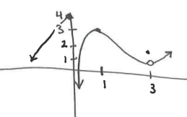

- Answer each of the following questions.
- Create a function that has the following properties.

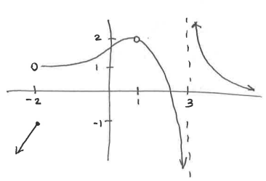


- Can you draw another function that meets all of the given conditions but has different behavior at the x-values of -2, 1, & 3?
Note that this question is asking about the specific behavior of the graph at these values of x and NOT the behavior of the graph around or approaching these x-values. Therefore this question wants to know if can be different while still meeting all the conditions from part (a). Since are part of the conditions of part (a) we can only change .
- Consider the function .
- Graph .
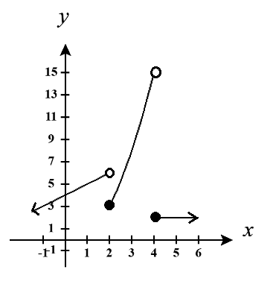

- Determine each of the following limits.

